Prediction of Gestational Diabetes via Logistic Regression

Group Project

##### import usful libraries

library(dplyr)

##   
## Attaching package: 'dplyr'

## The following objects are masked from 'package:stats':  
##   
## filter, lag

## The following objects are masked from 'package:base':  
##   
## intersect, setdiff, setequal, union

library(magrittr)  
library(knitr)  
library(ggplot2)

### A) Load the dataset in R Studio. Examine the first few rows of data using R. Explain your findings. Did you notice anything abnormal or interesting?

##### We first import the provided data set

patients <- read.csv("C:/Users/Z/Desktop/CIS 690/Group project/patients.csv")

##### To check and examine the data and the summary of the data

head(patients)

## Pregnancies Glucose BloodPressure SkinThickness Insulin BMI Pedigree Age  
## 1 6 148 72 35 0 33.6 0.627 50  
## 2 1 85 66 29 0 26.6 0.351 31  
## 3 8 183 64 0 0 23.3 0.672 32  
## 4 1 89 66 23 94 28.1 0.167 21  
## 5 0 137 40 35 168 43.1 2.288 33  
## 6 5 116 74 0 0 25.6 0.201 30  
## Diagnosis  
## 1 1  
## 2 0  
## 3 1  
## 4 0  
## 5 1  
## 6 0

summary(patients)

## Pregnancies Glucose BloodPressure SkinThickness   
## Min. : 0.000 Min. : 0.0 Min. : 0.00 Min. : 0.00   
## 1st Qu.: 1.000 1st Qu.: 99.0 1st Qu.: 62.00 1st Qu.: 0.00   
## Median : 3.000 Median :117.0 Median : 72.00 Median :23.00   
## Mean : 3.845 Mean :120.9 Mean : 69.11 Mean :20.54   
## 3rd Qu.: 6.000 3rd Qu.:140.2 3rd Qu.: 80.00 3rd Qu.:32.00   
## Max. :17.000 Max. :199.0 Max. :122.00 Max. :99.00   
## Insulin BMI Pedigree Age   
## Min. : 0.0 Min. : 0.00 Min. :0.0780 Min. :21.00   
## 1st Qu.: 0.0 1st Qu.:27.30 1st Qu.:0.2437 1st Qu.:24.00   
## Median : 30.5 Median :32.00 Median :0.3725 Median :29.00   
## Mean : 79.8 Mean :31.99 Mean :0.4719 Mean :33.24   
## 3rd Qu.:127.2 3rd Qu.:36.60 3rd Qu.:0.6262 3rd Qu.:41.00   
## Max. :846.0 Max. :67.10 Max. :2.4200 Max. :81.00   
## Diagnosis   
## Min. :0.000   
## 1st Qu.:0.000   
## Median :0.000   
## Mean :0.349   
## 3rd Qu.:1.000   
## Max. :1.000

from the summary table we can say that there are outliers in the data, also age , pedigree, pregnancies, insulin and glucose are positively skewed(mean>median) and blood pressure, skin thickness and bmi are negatively skewed(median>mean).

for insulin inter-quartile range looks larger compared to other features

In pregnancies, 0,1,2,3,4 are more compared to remaining values

### B) calculate the mean, median, sd and quartiles of all the features means of all the values

# For all the mean values   
pregnancies_mean <- mean(patients$Pregnancies)  
glucose_mean <- mean(patients$Glucose)  
bloodpressure_mean <- mean(patients$BloodPressure)  
skinThickness_mean <- mean(patients$SkinThickness)  
insulin_mean <- mean(patients$Insulin)  
bmi_mean <- mean(patients$BMI)  
pedigree_mean <- mean(patients$Pedigree)  
age_mean <- mean(patients$Age)  
  
# For all of the sd values  
pregnancies_sd <- sd(patients$Pregnancies)  
glucose_sd <- sd(patients$Glucose)  
blood_sd <- sd(patients$BloodPressure)  
skinth_sd <- sd(patients$SkinThickness)  
insulin_sd <- sd(patients$Insulin)  
bmi_sd <- sd(patients$BMI)  
pedigree_sd <- sd(patients$Pedigree)  
age_sd <- sd(patients$age)

#### To find the quartiles (where Q3 is 75% percentile, Q1 is the 25% percentile and Q2 is the 50% percentile which is the median)

##### To find the values of Q3

pregnancies_q3 <- quantile(patients$Pregnancies, 0.75)  
glucose_q3 <- quantile(patients$Glucose, 0.75)  
blood_q3 <- quantile(patients$BloodPressure, 0.75)  
skinThickness_q3 <- quantile(patients$SkinThickness, 0.75)  
insulin_q3 <- quantile(patients$Insulin, 0.75)  
bmi_q3 <- quantile(patients$BMI, 0.75)  
pedigree_q3 <- quantile(patients$Pedigree, 0.75)  
age_q3 <- quantile(patients$Age, 0.75)

##### To find the values of Q1

pregnancies_q1 <- quantile(patients$Pregnancies, 0.25)  
glucose_q1 <- quantile(patients$Glucose, 0.25)  
blood_q1 <- quantile(patients$BloodPressure, 0.25)  
skinThickness_q1 <- quantile(patients$SkinThickness, 0.25)  
insulin_q1 <- quantile(patients$Insulin, 0.25)  
bmi_q1 <- quantile(patients$BMI, 0.25)  
pedigree_q1 <- quantile(patients$Pedigree, 0.25)  
age_q1 <- quantile(patients$Age, 0.25)

##### And finally to find the values of Q2 (median), we can either use similar code or use the median function

pregnancies_q2 <- quantile(patients$Pregnancies, 0.5)  
glucose_q2 <- quantile(patients$Glucose, 0.5)  
blood_q2 <- quantile(patients$BloodPressure, 0.5)  
skinThickness_q2 <- quantile(patients$SkinThickness, 0.5)  
insulin_q2 <- quantile(patients$Insulin, 0.5)  
bmi_q2 <- quantile(patients$BMI, 0.5)  
pedigree_q2 <- quantile(patients$Pedigree, 0.5)  
age_q2 <- quantile(patients$Age, 0.5)

print(paste("Mean for pregnancies :",pregnancies_mean))

## [1] "Mean for pregnancies : 3.84505208333333"

print(paste("Mean for glucose :",glucose_mean))

## [1] "Mean for glucose : 120.89453125"

print(paste("Mean for blood pressure :",bloodpressure_mean))

## [1] "Mean for blood pressure : 69.10546875"

print(paste("Mean for skin thickness :",skinThickness_mean))

## [1] "Mean for skin thickness : 20.5364583333333"

print(paste("Mean for insulin :",insulin_mean))

## [1] "Mean for insulin : 79.7994791666667"

print(paste("Mean for bmi :",bmi_mean))

## [1] "Mean for bmi : 31.992578125"

print(paste("Mean for pedigree :",pedigree_mean))

## [1] "Mean for pedigree : 0.471876302083333"

print(paste("Mean for age :",age_mean))

## [1] "Mean for age : 33.2408854166667"

print(paste("Standard Deviation for pregnancies :",pregnancies_sd))

## [1] "Standard Deviation for pregnancies : 3.36957806269887"

print(paste("Standard Deviation for glucose :",glucose_sd))

## [1] "Standard Deviation for glucose : 31.9726181951362"

print(paste("Standard Deviation for blood pressure :",blood_sd))

## [1] "Standard Deviation for blood pressure : 19.3558071706448"

print(paste("Standard Deviation for skin thickness :",skinth_sd))

## [1] "Standard Deviation for skin thickness : 15.9522175677276"

print(paste("Standard Deviation for insulin :",insulin_sd))

## [1] "Standard Deviation for insulin : 115.244002351338"

print(paste("Standard Deviation for bmi :",bmi_sd))

## [1] "Standard Deviation for bmi : 7.88416032037545"

print(paste("Standard Deviation for pedigree :",pedigree_sd))

## [1] "Standard Deviation for pedigree : 0.331328595012775"

print(paste("Standard Deviation for age :",age_sd))

## [1] "Standard Deviation for age : NA"

print(paste("Q3 for pregnancies :",pregnancies_q3))

## [1] "Q3 for pregnancies : 6"

print(paste("Q3 for glucose :",glucose_q3))

## [1] "Q3 for glucose : 140.25"

print(paste("Q3 for blood pressure :",blood_q3))

## [1] "Q3 for blood pressure : 80"

print(paste("Q3 for skin thickness :",skinThickness_q3))

## [1] "Q3 for skin thickness : 32"

print(paste("Q3 for insulin :",insulin_q3))

## [1] "Q3 for insulin : 127.25"

print(paste("Q3 for bmi :",bmi_q3))

## [1] "Q3 for bmi : 36.6"

print(paste("Q3 for pedigree :",pedigree_q3))

## [1] "Q3 for pedigree : 0.62625"

print(paste("Q3 for age :",age_q3))

## [1] "Q3 for age : 41"

print(paste("Q1 for pregnancies :",pregnancies_q1))

## [1] "Q1 for pregnancies : 1"

print(paste("Q1 for glucose :",glucose_q1))

## [1] "Q1 for glucose : 99"

print(paste("Q1 for blood pressure :",blood_q1))

## [1] "Q1 for blood pressure : 62"

print(paste("Q1 for skin thickness :",skinThickness_q1))

## [1] "Q1 for skin thickness : 0"

print(paste("Q1 for insulin :",insulin_q1))

## [1] "Q1 for insulin : 0"

print(paste("Q1 for bmi :",bmi_q1))

## [1] "Q1 for bmi : 27.3"

print(paste("Q1 for pedigree :",pedigree_q1))

## [1] "Q1 for pedigree : 0.24375"

print(paste("Q1 for age :",age_q1))

## [1] "Q1 for age : 24"

print(paste("Q2 for pregnancies :",pregnancies_q2))

## [1] "Q2 for pregnancies : 3"

print(paste("Q2 for glucose :",glucose_q2))

## [1] "Q2 for glucose : 117"

print(paste("Q2 for blood pressure :",blood_q2))

## [1] "Q2 for blood pressure : 72"

print(paste("Q2 for skin thickness :",skinThickness_q2))

## [1] "Q2 for skin thickness : 23"

print(paste("Q2 for insulin :",insulin_q2))

## [1] "Q2 for insulin : 30.5"

print(paste("Q2 for bmi :",bmi_q2))

## [1] "Q2 for bmi : 32"

print(paste("Q2 for pedigree :",pedigree_q2))

## [1] "Q2 for pedigree : 0.3725"

print(paste("Q2 for age :",age_q2))

## [1] "Q2 for age : 29"

### C) Find missing values for each independent variable and fill them with median values. The missing values for independent variables in the dataset are coded 0.

# To first check for all missing values  
colSums(patients == 0)

## Pregnancies Glucose BloodPressure SkinThickness Insulin   
## 111 5 35 227 374   
## BMI Pedigree Age Diagnosis   
## 11 0 0 500

# To replace the missing values with median  
patients$Pregnancies[patients$Pregnancies==0]=median(patients$Pregnancies[patients$Pregnancies>0])  
  
patients$Glucose[patients$Glucose==0]=median(patients$Glucose[patients$Glucose>0])  
  
patients$BloodPressure[patients$BloodPressure==0]=median(patients$BloodPressure[patients$BloodPressure>0])  
  
patients$SkinThickness[patients$SkinThickness==0]=median(patients$SkinThickness[patients$SkinThickness>0])  
  
patients$Insulin[patients$Insulin==0]=median(patients$Insulin[patients$Insulin>0])  
  
patients$BMI[patients$BMI==0]=median(patients$BMI[patients$BMI>0])  
  
patients$Pedigree[patients$Pedigree==0]=median(patients$Pedigree[patients$Pedigree>0])  
  
patients$Age[patients$Age==0]=median(patients$Age[patients$Age>0])  
  
#To check for missing values or lack thereof  
colSums(patients == 0)

## Pregnancies Glucose BloodPressure SkinThickness Insulin   
## 0 0 0 0 0   
## BMI Pedigree Age Diagnosis   
## 0 0 0 500

### 

There are no null values in Pedigree and Age, and the remaining independent variables have some null values. After Replacing the null values in independent variables with median, there are no more null values there are more missing values in insulin compared to other features.

The preprocessing stage of our research also included checking for missing values and outliers.   
In order to find missing values in the dataset, which were indicated as 0 in the dataset, we used *colSums(patients==0)* function. We then substituted the missing values with medians of corresponding variables.

### D) Find outliers for each independent variable using the IQR rule

# To find the outliers using the IQR rule  
preg_out1 = pregnancies_q3 + ((pregnancies_q3 - pregnancies_q1) * 1.5)  
preg_out2 = pregnancies_q1 - ((pregnancies_q3 - pregnancies_q1) * 1.5)  
  
glucose_out1 = glucose_q3 + ((glucose_q3 - glucose_q1) * 1.5)  
glucose_out2 = glucose_q1 - ((glucose_q3 - glucose_q1) * 1.5)   
  
blood_out1 = blood_q3 + ((blood_q3 - blood_q1) * 1.5)  
blood_out2 = blood_q1 - ((blood_q3 - blood_q1) * 1.5)  
  
skinThickness_out1 = skinThickness_q3 + ((skinThickness_q3 - skinThickness_q1) * 1.5)  
skinThickness_out2 = skinThickness_q1 - ((skinThickness_q3 - skinThickness_q1) * 1.5)  
  
insulin_out1 = insulin_q3 + ((insulin_q3 - insulin_q1) * 1.5)  
insulin_out2 = insulin_q1 - ((insulin_q3 - insulin_q1) * 1.5)  
  
bmi_out1 = bmi_q3 + ((bmi_q3 - bmi_q1) * 1.5)  
bmi_out2 = bmi_q1 - ((bmi_q3 - bmi_q1) * 1.5)  
  
pedigree_out1 = pedigree_q3 + ((pedigree_q3 - pedigree_q1) * 1.5)  
pedigree_out2 = pedigree_q1 - ((pedigree_q3 - pedigree_q1) * 1.5)  
  
age_out1 = age_q3 + ((age_q3 - age_q1) * 1.5)  
age_out2 = age_q1 - ((age_q3 - age_q1) * 1.5)

# To check the outliers using boxplots  
boxplot(x=patients$Pregnancies)

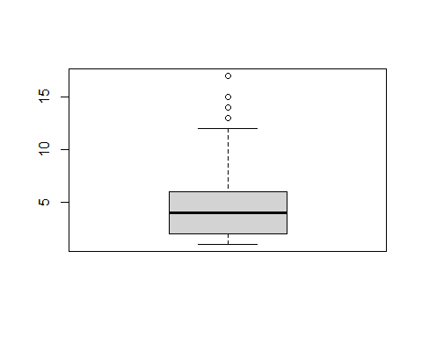

boxplot(x=patients$Glucose)

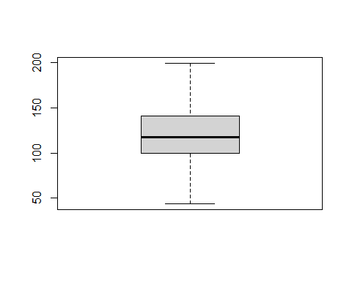

boxplot(x=patients$BloodPressure)

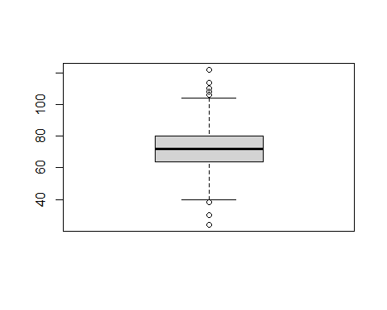

boxplot(x=patients$SkinThickness)

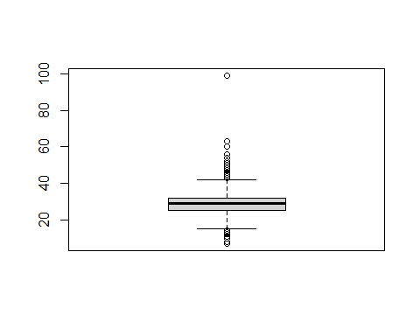

boxplot(x=patients$Insulin)

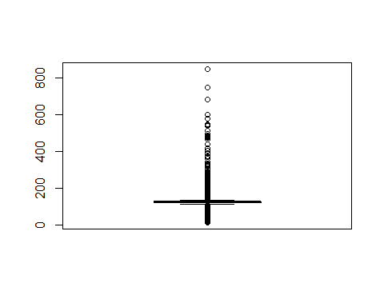

boxplot(x=patients$BMI)

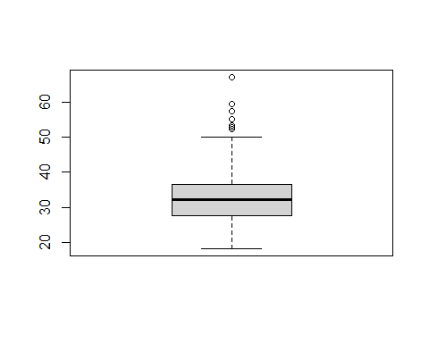

boxplot(x=patients$Pedigree)

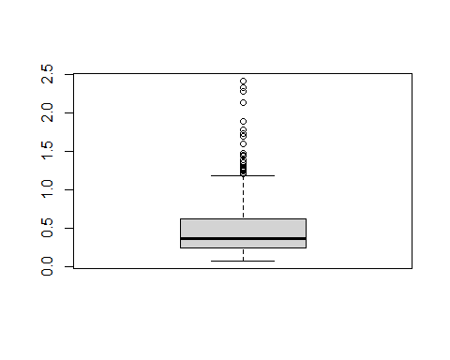

boxplot(x=patients$Age)

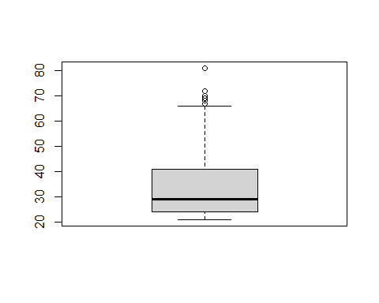

##### To now check and find what the outliers are for each of the features

# pregnancies   
preg_out1

## 75%   
## 13.5

preg_out2

## 25%   
## -6.5

# Since glucose does not have any outliers (as observed in the box plot)  
  
# blood pressure  
blood_out1

## 75%   
## 107

blood_out2

## 25%   
## 35

# Skin Thickness  
skinThickness_out1

## 75%   
## 80

skinThickness_out2

## 25%   
## -48

# insulin  
insulin_out1

## 75%   
## 318.125

insulin_out2

## 25%   
## -190.875

# BMI  
bmi_out1

## 75%   
## 50.55

bmi_out2

## 25%   
## 13.35

# pedigree  
pedigree_out1

## 75%   
## 1.2

pedigree_out2

## 25%   
## -0.33

# age  
age_out1

## 75%   
## 66.5

age_out2

## 25%   
## -1.5

### 

### E) Replace outliers with median Values.

# for pregnancies  
  
patients.clean <- patients %>%  
 mutate(Pregnancies = replace(Pregnancies, Pregnancies > preg_out1, median(Pregnancies)))  
  
# to check  
preg_out <- boxplot.stats(patients.clean$Pregnancies)$out  
preg_out

## [1] 13 13 13 13 13 13 13 13 13 13

boxplot(x=patients.clean$Pregnancies)

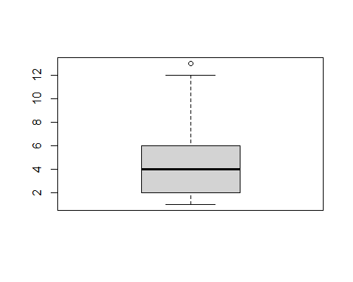

# for glucose - There are no medians as we observed from the box plot   
# to check  
glucose_out <- boxplot.stats(patients.clean$Glucose)$out  
glucose_out

## integer(0)

# for blood pressure  
patients.clean <- patients %>%  
 mutate(BloodPressure = replace(BloodPressure, BloodPressure > 104, median(BloodPressure)))  
patients.clean <- patients %>%  
 mutate(BloodPressure = replace(BloodPressure, BloodPressure < 40, median(BloodPressure)))  
  
# to check  
bloodp_out <- boxplot.stats(patients.clean$BloodPressure)$out  
bloodp_out

## [1] 110 108 122 110 108 110 106 106 106 114

boxplot(x=patients.clean$BloodPressure)

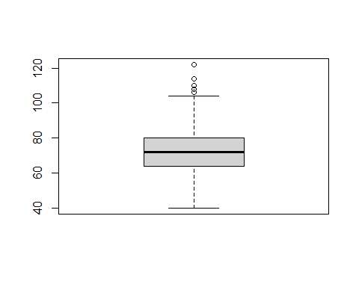

# For skin thickness  
patients.clean <- patients %>%  
 mutate(SkinThickness = replace(SkinThickness, SkinThickness > skinThickness_out1, median(SkinThickness)))  
patients.clean <- patients %>%  
 mutate(SkinThickness = replace(SkinThickness, SkinThickness < skinThickness_out2, median(SkinThickness)))  
  
# to check  
skinT_out <- boxplot.stats(patients.clean$SkinThickness)$out  
skinT_out

## [1] 45 47 11 47 11 10 60 13 13 54 51 56 14 13 50 44 12 46 44 13 44 54 14 7 50  
## [26] 52 10 44 43 45 14 10 11 12 43 13 12 48 43 43 8 13 14 12 49 46 46 11 8 12  
## [51] 63 12 45 13 48 13 10 45 7 52 49 43 14 47 99 46 11 50 45 14 13 13 47 12 48  
## [76] 43 46 46 45 10 46 49 11 13 46 44 48

# for insulin  
patients.clean <- patients %>%  
 mutate(Insulin = replace(Insulin, Insulin > insulin_out1, median(Insulin)))  
patients.clean <- patients %>%  
 mutate(Insulin = replace(Insulin, Insulin < insulin_out2, median(Insulin)))  
  
# to check  
insulin_out <- boxplot.stats(patients.clean$Insulin)$out  
insulin_out

## [1] 94 168 88 543 846 175 230 83 96 235 146 140 110 245 54 192 207 70  
## [19] 240 82 36 23 300 342 304 110 142 38 100 90 140 270 71 71 110 176  
## [37] 48 64 228 76 64 220 40 152 140 18 36 495 37 175 51 100 100 99  
## [55] 94 145 168 225 49 140 50 92 325 63 284 204 155 485 94 53 105 285  
## [73] 156 78 48 55 92 23 495 58 160 94 210 48 99 318 44 190 280 87  
## [91] 175 271 478 190 56 32 744 53 370 37 45 192 88 176 194 680 402 55  
## [109] 258 375 150 67 56 45 57 278 155 545 220 49 75 40 74 182 194 360  
## [127] 215 184 42 105 148 180 205 148 96 85 94 64 140 231 29 168 156 68  
## [145] 52 58 255 171 105 73 108 83 74 43 167 54 249 325 293 83 66 140  
## [163] 465 89 66 94 158 325 84 75 72 82 182 59 110 50 285 81 196 415  
## [181] 87 275 88 165 579 176 310 61 167 474 170 76 78 210 277 180 145 180  
## [199] 85 60 50 14 70 92 64 63 95 210 105 71 237 60 56 49 105 36  
## [217] 100 140 191 110 75 328 49 250 480 265 66 76 145 193 71 79 90 170  
## [235] 76 210 86 105 165 326 66 82 105 188 106 65 56 210 155 215 190 56  
## [253] 76 225 207 166 67 106 44 215 274 77 54 88 18 165 44 330 63 600  
## [271] 156 140 230 185 25 293 41 272 182 158 194 321 144 15 160 54 90 183  
## [289] 66 91 46 105 152 440 144 159 100 106 77 540 90 200 70 231 190 100  
## [307] 168 49 240 265 45 105 205 180 180 95 480 155 200 100 335 160 387 22  
## [325] 291 392 185 178 200 105 180 79 165 160 150 94 140 105 57 200 74 510  
## [343] 110 16 180

# for BMI  
patients.clean <- patients %>%  
 mutate(BMI = replace(BMI, BMI > bmi_out1, median(BMI)))  
patients.clean <- patients %>%  
 mutate(BMI = replace(BMI, BMI < bmi_out2, median(BMI)))  
  
# to check  
bmi_out <- boxplot.stats(patients.clean$BMI)$out  
bmi_out

## [1] 53.2 55.0 67.1 52.3 52.3 52.9 59.4 57.3

# for pedigree  
patients.clean <- patients %>%  
 mutate(Pedigree = replace(Pedigree, Pedigree > pedigree_out1, median(Pedigree)))  
patients.clean <- patients %>%  
 mutate(Pedigree = replace(Pedigree, Pedigree < pedigree_out1, median(Pedigree)))  
  
# to check  
pedigree_out <- boxplot.stats(patients.clean$Pedigree)$out  
pedigree_out

## [1] 2.288 1.441 1.390 1.893 1.781 1.222 1.400 1.321 1.224 2.329 1.318 1.213  
## [13] 1.353 1.224 1.391 1.476 2.137 1.731 1.268 1.600 2.420 1.251 1.699 1.258  
## [25] 1.282 1.698 1.461 1.292 1.394

# for age  
patients.clean <- patients %>%  
 mutate(Age = replace(Age, Age > age_out1, median(Age)))  
patients.clean <- patients %>%  
 mutate(Age = replace(Age, Age < age_out2, median(Age)))  
  
# to check  
age_out <- boxplot.stats(patients.clean$Age)$out  
age_out

## [1] 69 67 72 81 67 67 70 68 69

##### To check the updated boxplots for observing the changes in outliers

boxplot(x=patients.clean$Pregnancies)



boxplot(x=patients.clean$Glucose)



boxplot(x=patients.clean$BloodPressure)



boxplot(x=patients.clean$SkinThickness)



boxplot(x=patients.clean$Insulin)



boxplot(x=patients.clean$BMI)



boxplot(x=patients.clean$Pedigree)



boxplot(x=patients.clean$Age)



### F) Find the best performing variables / features using a correlogram.

library(corrplot)

## corrplot 0.92 loaded

P.cor <- cor(patients)  
head(round(P.cor,2))

## Pregnancies Glucose BloodPressure SkinThickness Insulin BMI  
## Pregnancies 1.00 0.15 0.26 0.13 0.03 0.10  
## Glucose 0.15 1.00 0.22 0.19 0.42 0.23  
## BloodPressure 0.26 0.22 1.00 0.19 0.05 0.28  
## SkinThickness 0.13 0.19 0.19 1.00 0.16 0.54  
## Insulin 0.03 0.42 0.05 0.16 1.00 0.18  
## BMI 0.10 0.23 0.28 0.54 0.18 1.00  
## Pedigree Age Diagnosis  
## Pregnancies -0.01 0.52 0.25  
## Glucose 0.14 0.27 0.49  
## BloodPressure 0.00 0.32 0.17  
## SkinThickness 0.10 0.13 0.21  
## Insulin 0.13 0.10 0.20  
## BMI 0.15 0.03 0.31

corrplot(P.cor, method = "color", addCoef.col = "black")

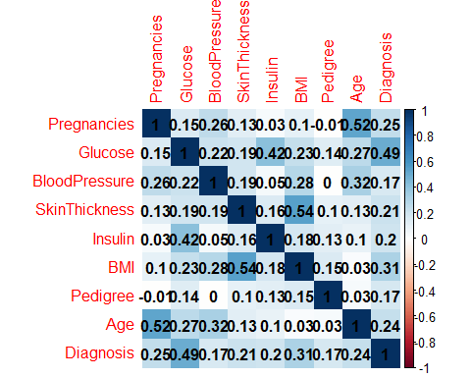

Correlation is a statistical term which in common usage refers to how close two variables are to having a linear relationship with each other.

The most highly correlated features are (Diagnosis is our target function):

* Glucose=0.49
* BMI = 0.31
* Pregnancies = 0.25.

These are the features that we have chosen for our analysis of our first Regression Model.

### G. Standardaize your features to Guassian distribution

# to standardize the data, we first split the data for training and testing using a 70/30 split  
dt = sort(sample(nrow(patients), nrow(patients)*.7))  
#head(dt)  
traindata <- patients[dt,]  
testdata <- patients[-dt,]  
#head(traindata)  
# And to now standardize both the train and test data  
  
xtrain <- as.data.frame(scale(traindata[1:8]))  
xtest <- as.data.frame(scale(testdata[1:8]))  
  
head(xtrain)

## Pregnancies Glucose BloodPressure SkinThickness Insulin BMI  
## 1 0.5221283 0.8663014 -0.0261782 0.677738918 -0.1918371 0.1990446  
## 2 -1.1428533 -1.2005422 -0.5252679 -0.009816118 -0.1918371 -0.8263200  
## 3 1.1881210 2.0145479 -0.6916311 -0.009816118 -0.1918371 -1.3097061  
## 4 -1.1428533 -1.0693141 -0.5252679 -0.697371154 -0.5320793 -0.6065990  
## 5 -0.1438643 0.5054239 -2.6879899 0.677738918 0.2801116 1.5906108  
## 6 0.1891320 -0.1835239 0.1401850 -0.009816118 -0.1918371 -0.9728006  
## Pedigree Age  
## 1 0.4882792 1.3856521  
## 2 -0.3589822 -0.2152774  
## 3 0.6264196 -0.1310180  
## 4 -0.9238232 -1.0578719  
## 5 5.5871967 -0.0467585  
## 6 -0.8194504 -0.2995368

#head(xtest)

Before we build any model we will standardize features with gaussian distribution.

It is one of the **scaling technique where the values are centered around the mean with a unit standard deviation**.

So here all the independent variables are transformed in such a way that it will have properties of a standard normal distribution with mean = 0 and standard deviation = 1.

### H) Create a logistic regression model (call it LRM1) using your best features. Describe your model.

# We will first set the seed so that we can have a constant out put  
set.seed(1)  
  
# we will then use 70% of the split data as training and the remaining 30% as testing.   
# Before running the LRM1 we will first add the target function (diagnosis) back to our train and test data sets  
  
xtrain$Diagnosis <- traindata$Diagnosis  
  
xtest$Diagnosis <- testdata$Diagnosis  
  
# We then ran the LRM1 model  
options(scipen = 999)  
LRM1 <- glm(Diagnosis~Glucose+Pregnancies+BMI, family = "binomial",data=xtrain)  
  
summary(LRM1)

##   
## Call:  
## glm(formula = Diagnosis ~ Glucose + Pregnancies + BMI, family = "binomial",   
## data = xtrain)  
##   
## Deviance Residuals:   
## Min 1Q Median 3Q Max   
## -2.21811 -0.7224 -0.4022 0.7078 2.3844   
##   
## Coefficients:  
## Estimate Std. Error z value Pr(>|z|)   
## (Intercept) -0.9250 0.1161 -7.967 0.00000000000296 ***  
## Glucose 1.0257 0.1242 8.255 < 0.0000000000000002 ***  
## Pregnancies 0.5202 0.1116 4.662 0.00001886037909 ***  
## BMI 0.6652 0.1240 5.362 0.00000005854564 ***  
## ---  
## Signif. codes: 0 '***' 0.001 '**' 0.01 '*' 0.05 '.' 0.1 ' ' 1  
##   
## (Dispersion parameter for binomial family taken to be 1)  
##   
## Null deviance: 686.36 on 536 degrees of freedom  
## Residual deviance: 502.88 on 533 degrees of freedom  
## AIC: 510.88  
##   
## Number of Fisher Scoring iterations: 5

# to predict the outcome of the training set   
predictTrain1 <- predict(LRM1, newdata= xtest, type = "response")  
summary(predictTrain1)

## Min. 1st Qu. Median Mean 3rd Qu. Max.   
## 0.01256 0.121163 0.25385 0.33693 0.55622 0.91275

### Here we are considering our best features Glucose, Pregnancies and BMI. We are only considering these three features as they have correlation with the target variable Diagnosis. And also, Pregnancies and BMI has high correlation with independent variables age and skin Thickness respectively. So, we thought it’s better to consider Glucose, Pregnancies and BMI for first model LRM1.

### I) Create a classification report of your model.

threshold_0.5_1 <- table(xtest$Diagnosis, predictTrain1 > 0.5)  
threshold_0.5_1

##   
## FALSE TRUE  
## 0 142 17  
## 1 26 46

### Classification report is an evaluation metric to compare true labels of our data to predicted labels from our built model, so we can know how our model is performing. Classification report is built from confusion Matrix which has true negatives, true positives, false negatives and false positives. From above confusion matrix, we can see true positives as 46 and true negatives as 142

### J) Describe your classification report (precision, recall, F1 score, and support).

err_metric=function(CM)  
{  
 TN =CM[1,1]  
 TP =CM[2,2]  
 FP =CM[1,2]  
 FN =CM[2,1]  
 precision =(TP)/(TP+FP)  
 recall_score =(FP)/(FP+TN)  
   
 f1_score=2*((precision*recall_score)/(precision+recall_score))  
 accuracy_model =(TP+TN)/(TP+TN+FP+FN)  
 False_positive_rate =(FP)/(FP+TN)  
 False_negative_rate =(FN)/(FN+TP)  
   
 print(paste("Precision value of the model: ",round(precision,2)))  
 print(paste("Accuracy of the model: ",round(accuracy_model,2)))  
 print(paste("Recall value of the model: ",round(recall_score,2)))  
 print(paste("False Positive rate of the model: ",round(False_positive_rate,2)))  
   
 print(paste("False Negative rate of the model: ",round(False_negative_rate,2)))  
   
 print(paste("f1 score of the model: ",round(f1_score,2)))  
}  
err_metric(threshold_0.5_1)

## [1] "Precision value of the model: 0.73"  
## [1] "Accuracy of the model: 0.81"  
## [1] "Recall value of the model: 0.11"  
## [1] "False Positive rate of the model: 0.11"  
## [1] "False Negative rate of the model: 0.36"  
## [1] "f1 score of the model: 0.19"

* **Accuracy** – It tells how many times we predicted correctly as our true data labels. 0.81
* **Precision** - When model predicts true, how often it was right? 0.73
* **Recall -** When the class was actually true , how often or class get it right? 0.11
* **F1Score** – combination of both precision and recall. 0.19

Even though Accuracy and Precision are high, Recall and F1Score are less

Recall below mean that our models was able to detect less no of patients having diabetes when we have more, which is kind of bad, so it better to deploy models like SVM etc than going with logistic regression.

### K) Create the accuracy score of your model. Describe the accuracy score.

accuracy_0.5 <- round(sum(diag(threshold_0.5_1))/sum(threshold_0.5_1),2)  
sprintf("Accuracy is %s",accuracy_0.5)

## [1] "Accuracy is 0.81"

#Mis-classification error rate  
  
MC_0.5 <- 1-accuracy_0.5  
sprintf("Mis-classification error is %s",MC_0.5)

## [1] "Mis-classification error is 0.19"

* **Accuracy** – It tells how many times we predicted correctly as our true data labels. 0.81

Our model accuracy is good, that means our model has high prediction rate with correct diagnosis.

Misclassification rate is like measuring how messed up our model is which is 1-accuracy i.e 0.19

### L) Create another logistic regression model (call it LRM2). Use all the independent features this time (instead of your best performing features).

LRM2 <- glm(Diagnosis ~ Pregnancies + Glucose +Insulin + BloodPressure + SkinThickness + BMI + Age + Pedigree, family="binomial", data=xtrain)  
  
summary(LRM2)

##   
## Call:  
## glm(formula = Diagnosis ~ Pregnancies + Glucose + Insulin + BloodPressure +   
## SkinThickness + BMI + Age + Pedigree, family = "binomial",   
## data = xtrain)  
##   
## Deviance Residuals:   
## Min 1Q Median 3Q Max   
## -2.6678 -0.7531 -0.4332 0.7453 2.3256   
##   
## Coefficients:  
## Estimate Std. Error z value Pr(>|z|)   
## (Intercept) -0.85207 0.11281 -7.553 0.0000000000004238 ***  
## Pregnancies 0.42742 0.12523 3.413 0.000642 ***  
## Glucose 1.04188 0.13390 7.781 0.0000000000000719 ***  
## Insulin 0.01283 0.11860 0.108 0.913888   
## BloodPressure -0.14544 0.12065 -1.205 0.228017   
## SkinThickness 0.09712 0.14050 0.691 0.489412   
## BMI 0.45679 0.14116 3.236 0.001212 ***  
## Age 0.16895 0.12724 1.328 0.184240   
## Pedigree 0.24586 0.11301 2.175 0.029594 *   
## ---  
## Signif. codes: 0 '***' 0.001 '**' 0.01 '*' 0.05 '.' 0.1 ' ' 1  
##   
## (Dispersion parameter for binomial family taken to be 1)  
##   
## Null deviance: 619.63 on 536 degrees of freedom  
## Residual deviance: 519.76 on 528 degrees of freedom  
## AIC: 537.76  
##   
## Number of Fisher Scoring iterations: 4

predictTrain2 <- predict(LRM2, newdata= xtest, type = "response")  
summary(predictTrain2)

## Min. 1st Qu. Median Mean 3rd Qu. Max.   
## 0.01496 0.11306 0.27422 0.35069 0.56120 0.98783

threshold_0.5_2 <- table(xtest$Diagnosis, predictTrain2 > 0.5)  
threshold_0.5_2

##   
## FALSE TRUE  
## 0 131 17  
## 1 34 49

accuracy_0.5 <- round(sum(diag(threshold_0.5_2))/sum(threshold_0.5_2),2)  
sprintf("Accuracy is %s",accuracy_0.5)

## [1] "Accuracy is 0.78"

MC_0.5 <- 1-accuracy_0.5  
sprintf("Mis-classification error is %s",MC_0.5)

## [1] "Mis-classification error is 0.22"

err_metric=function(CM)  
{  
 TN =CM[1,1]  
 TP =CM[2,2]  
 FP =CM[1,2]  
 FN =CM[2,1]  
 precision =(TP)/(TP+FP)  
 recall_score =(FP)/(FP+TN)  
   
 f1_score=2*((precision*recall_score)/(precision+recall_score))  
 accuracy_model =(TP+TN)/(TP+TN+FP+FN)  
 False_positive_rate =(FP)/(FP+TN)  
 False_negative_rate =(FN)/(FN+TP)  
   
 print(paste("Precision value of the model: ",round(precision,2)))  
 print(paste("Accuracy of the model: ",round(accuracy_model,2)))  
 print(paste("Recall value of the model: ",round(recall_score,2)))  
 print(paste("False Positive rate of the model: ",round(False_positive_rate,2)))  
   
 print(paste("False Negative rate of the model: ",round(False_negative_rate,2)))  
   
 print(paste("f1 score of the model: ",round(f1_score,2)))  
}  
err_metric(threshold_0.5_2)

## [1] "Precision value of the model: 0.74"  
## [1] "Accuracy of the model: 0.78"  
## [1] "Recall value of the model: 0.11"  
## [1] "False Positive rate of the model: 0.11"  
## [1] "False Negative rate of the model: 0.41"  
## [1] "f1 score of the model: 0.2"

Finally, for our second logistic regression model in addition to highly correlated features: pregnancies, glucose and BMI, we used all independent features listed in our dataset, those were: Insulin, SkinThickness, Age, BloodPressure, Pedigree.

Based on p-values, we can see that, as mentioned before, Pregnancies, Glucose, BMI are significant features (p-value < 0.05), however we see that Pedigree can also be considered significant as its p-value is less than 0.05.   
The Null deviance or fit dependent variable for the model is 619.63  
The Residual deviance/ fit dependent variable with all independent variable is 519.76. This big difference between Null deviance and Residual deviance means that our model significantly improved.   
Akaike’s Information Criterion is 537.76 with 78% of Accuracy and 74% Precision rates. The less the AIC value the better the model.

F1 score – combination of precision and recall is 0.20.

### M) Compare the two models (LRM1 and LRM2) based on the classification report and accuracy score. Which one is a better model? Why?

AIC(LRM1,LRM2)

## df AIC  
## LRM1 4 510.88  
## LRM2 9 537.76

library(caTools)  
library(ROCR)   
   
ROCPred <- prediction(predictTrain1, xtest$Diagnosis)   
ROCPer <- performance(ROCPred, measure = "tpr",   
 x.measure = "fpr")  
  
auc <- performance(ROCPred, measure = "auc")  
auc <- auc@y.values[[1]]  
auc

## [1] 0.857094

plot(ROCPer)

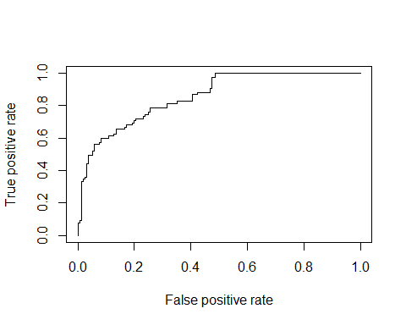

plot(ROCPer, colorize = TRUE,   
 print.cutoffs.at = seq(0.1, by = 0.1),   
 main = "ROC CURVE")  
abline(a = 0, b = 1)  
   
auc <- round(auc, 4)  
legend(.6, .4, auc, title = "AUC", cex = 1)

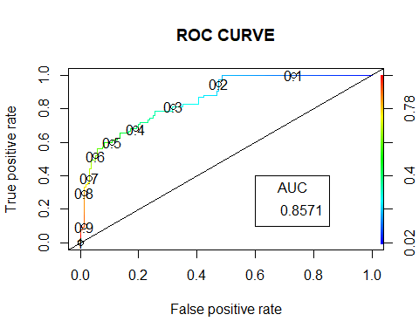

library(caTools)  
library(ROCR)   
   
ROCPred <- prediction(predictTrain2, xtest$Diagnosis)   
ROCPer <- performance(ROCPred, measure = "tpr",   
 x.measure = "fpr")  
  
auc <- performance(ROCPred, measure = "auc")  
auc <- auc@y.values[[1]]  
auc

## [1] 0.8547863

plot(ROCPer)

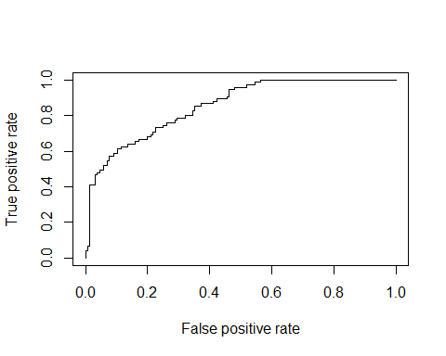

plot(ROCPer, colorize = TRUE,   
 print.cutoffs.at = seq(0.1, by = 0.1),   
 main = "ROC CURVE")  
abline(a = 0, b = 1)  
   
auc <- round(auc, 4)  
legend(.6, .4, auc, title = "AUC", cex = 1)

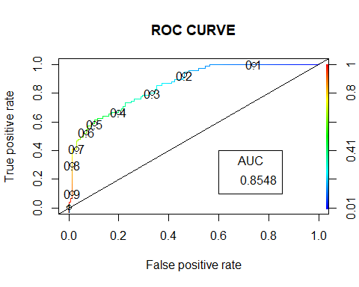

### 

### We start off by comparing deviance differences of models. Null deviance is the value when you only have intercept in your equation with no variables and Residual deviance is the value when you are taking all the variables into account. The greater the difference between Null deviance and Residual deviance the better the fit of the model. For the first model the deviance difference was 184 and for the second model it was 172. Based only on that we can say that the first model is performing better.

### Next, let’s compare accuracy scores. The greater the accuracy value the better the model can predict diagnosis. The first model had an accuracy of 81%, the second model = 78%. Again, the first model has greater accuracy, and it is performing better.

### Next, compare Akaike’s Information Criterion or AIC, which is an estimator of prediction error and thereby relative quality of statistical models for a given set of data. The lower AIC value the better the model! We had LRM1 = 510.88, LRM2 = 537.76. The first model shas lower AIC value, hence it is performing better than the second value.

### Area under the ROC curve - absolute value of quality of prediction, with maximum of 1 meaning perfect prediction. LRM1 = 0.8705. LRM2 = 0.8754. The difference between them is about 0.001, which is not a huge difference, however if we look at the ROC curve, we see that the first model has 0.61-0.62 true positive rate ay a threshold of 0.5, while ROC curve for the second model has 0.59-0.60 true positive rate at a threshold of 0.5. This means that our first model has a better-quality prediction than the second model.

### N) What would be your suggestions for further improving the accuracy of your chosen model?

##### Based on the models that we made and the results we had found when running said models, we concluded that:

##### Increasing the data collected and to also make sure to diversify the sample collected to represent more demographics to better resemble the population would yield better results. This we believe is true not only for our models but in real world applications as well.

##### We also suggest that finetuning the parameters used could potentially result in the model providing better predictions. We have observed such occurrences when using different threshold values. In the end, we used a threshold value of 0.5 as it is the more recommended value. But when using different values, we observed that not only did the models perform at varying levels but also at times the performance levels shifted as my teammate eluded on the AUC curves where the second model performed better than the first in few of the values, but this leads us to assume that further investigation and analysis could yield better performance from our models.

##### And finally, our group strongly suggests that better feature selection would aid in improving the accuracy of the chosen model. Since we had only included the top 3 highly correlated features for our selected model, we believe that if we diversified and included other features that may not be as closely correlated to our target function and try different combinations of the features, this could yield with better prediction performance.

### O) What would be the pitfalls or weaknesses of your model if the hospital decided to deploy it to predict diabetes?

##### The first one is that there could be a possible ethical pitfall.

##### In the research that we have done, we observed this being mentioned a couple of times. One of the main ethical pitfalls experienced by medical personnel of any health institution is that their diagnosis of their patients is always derived from the data they collect about the patient. Sometimes more data is collected to help clarify or better classify a patient’s symptoms to aid in a final diagnosis but even with that, they could end up wrongfully diagnosing a patient, which is common in the medical field. If the hospital were to implement this model to help aid their medical personnel in concluding a patient’s diagnosis and this has a negative outcome either because the model provided the wrong prediction or conclusion or due to a wrongful data entry, the fault would still be on the medical doctor that mis-diagnosed the patient and hence might have either caused more issues and damage to the patient or was unhelpful. The other side of this, is that if the doctor provides sufficient data to the model and the model predicts a certain diagnosis and the doctor does not agree with this conclusion and ends up being wrong, then again, they would be held accountable for not only wrongful diagnosis of the patient but also not following protocol or the results provided from the ML model.

##### The next pitfall we want to point out is that the model would not predict effectively to patients that might fall into the, what we considered as, outliers. We say this because as discussed earlier, we have replaced these outliers with the median values of each of these features. This reduces the accuracy of the model to predict a correct diagnosis of any patients that might have values that fall into said outliers.

##### The final pitfall could be that the model would only be effective on patients with demographics, races or areas that the sample was taken from. This could cause a big bias to communities that were not included in the collected sample, and this could result in wrongful diagnosis if the model is used on such patients. For example, if the training and test data for the algorithm during development predominantly involves medical cases of middle-aged Westerners, its medical diagnosis might be less accurate regarding people with East Asian ancestry. Due to different dietary habits or genetic predispositions, the latter might be prone to developing the disease due to different causes or data values compared with the former. Thus, the machine learning algorithm might face difficulties at providing a reliable medical diagnosis for a patient coming from Eastern Asia.

### P) If you were to present your analysis and findings to the CEO of the hospital, what would be your top five key points?

##### The first point we would like to mention is that when observing the different features that are included in the diagnosis of a patient as to whether they have gestational diabetes, we saw that not all the features have a direct or normal correlation to the diagnosis. This means that not all the data collected from the patients is equally useful for the model’s prediction accuracy. So, we advise that you pay more attention to these values when conducting the health screenings of your patients.

##### The second point we would like to make is that based on the models we tested, as mentioned above on our first point, not all of the features are needed to better predict the diagnosis of a patient using our ML model. Unlike medical personnel this model would not necessarily perform better when provided with more features but would be more effective when a select few of the features are used. As mentioned previously in our presentation, we created and tested two models, the first only containing three of our more highly correlated features and the second containing all the provided features. And we have seen that the first model performs better in predicting the diagnosis of the patients more accurately. Hence, you should always pay more attention to the features provided to the ML model and make sure to select what would aid the model to perform better and not to add more features with the expectation of better results.

##### The third point we would like to make is that because we developed our models based on some assumptions and redacted the data based on those assumptions, we must be very vigilant when deploying the ML model and the patients we are using them for. For instance, one of the adjustments we had made was to replace all the data outliers with the median value. When this was done, some of the data points were ultimately altered; hence the ML model would only best predict and work accurately for patients that were in the adjusted data used to create said model.

##### The fourth point we would like to make is that this ML model could be used for potential future diagnosis of patients that have certain values in their data that is similar to patients that have had a positive result to having gestational diabetes in the past. This could be implemented to use caution and better prepare patients that plan for pregnancies of for patients that recently have gotten pregnant. If their data shows that they are more prone to having or developing gestational diabetes, then their physicians could warn them to take better care and lookout for any signs which could help prevent said patients from developing gestational diabetes.

##### And finally, our fifth point, going off the fourth, is that by using this model you would also be able to create a treatment plan that is more individualized. You could tackle issues with patients that have high values in certain features in their data that have proven to be more correlated and could result in a positive diagnosis of gestational diabetes. You can develop on the existing model by documenting the treatments used for your patients to find which treatments were most effective to help the patient in overcoming the disease. For instance, if a patient is diagnosed as having gestational diabetes and one can observe that the patient’s glucose levels are high and when comparing all other features in the data and they do not show any differences with other patients that do not have gestational diabetes, this could be indicative of the cause of the disease and a good insight as to what type of treatment would best suit this patient. Using this ML model, you would not only be able to foresee and prevent your patients from developing gestational diabetes but also in the case that they do develop this disease, you would be better equipped and prepared to treat your patients in the most effective way. This would not only help save costs of treatments both for your patients and your intuition, but it would result in high patient satisfaction and a much smoother working and operating institution overall.

#### Thank you.